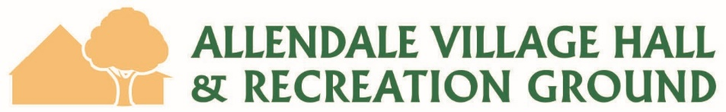

Conditions for Licenced Use of Premises

Allendale Village Hall has a Premises Licence which authorises the sale and provision of alcohol and other regulated entertainment. The Trustees of Allendale Village Hall are the Licence Holders. Licenced hours for the sale of alcohol and other regulated entertainment are 10:00 am to 01:00 am.
Hirers of the hall who would like to sell alcohol may do so under the Allendale Village Hall Premises Licence on the following conditions:
- Payment of the third-party bar fee listed in the current schedule of Hire Charges.
- Completion of a Hire Agreement designating a Responsible Person. The Responsible Person must be approved by the Trustees.
- The Responsible Person and appointed bar staff to read these Conditions.
The Premises Licence does not cover the Recreation Ground. A Temporary Events Notice must be obtained from Northumberland County Council for any regulated entertainment or alcohol supply in the Recreation Ground.
All sales or supply of alcohol must be made under the supervision of the Responsible Person, who must be present at the event whenever alcohol is sold or supplied.
The Responsible Person and any bar staff must uphold the four objectives of the Licensing Act 2003:
- the prevention of crime and disorder
- the promotion of public safety
- the prevention of public nuisance
- the protection of children from harm
and must not:
- sell or supply alcohol outside the licensed hours
- sell or allow the sale of alcohol to anyone under 18
- allow the consumption of alcohol on the premises by anyone under the age of 18
- allow any person under the age of 18 to sell or supply alcohol
- allow the sale or supply of alcohol to any person who is drunk
- allow disorderly conduct on the premises

Any incidents or refusals to sell or supply alcohol must be recorded in the books provided which must be kept behind the bar.
Alcohol must not be left unattended in the Village Hall unless securely locked up – this is part of our Safeguarding Policy.

Guidance Notes
It is against the law to sell or provide alcohol to persons under the age of 18.
Be Cautious – it is very hard to tell a young person’s age, so ensure that you check even those that look older than 18. If they look 25 or under then check for proof.
Be Consistent – always check, even if you think you’ve served the young person before or you are pretty certain they are of the right age.
Be Clear – use signage to inform people that they will be checked. Signs are provided by the Hall Committee.
Be Courteous – if you have to refuse a sale explain that you are complying with the Law and advise the young person that they can obtain a proof of age card.
Be Conscientious – ensure that you record all refusals including date, time, appearance of the young person, items refused and your name for every refusal. A refusals book is provided by the Hall Committee and must be kept behind the bar at all times.
Be Careful – there is evidence that bar staff can often fail to challenge underage purchasers if they feel afraid of the consequences. Make sure alcohol is only sold from the drinks bar or the food service bar.
The Portman Group offers a free booklet, “Saying no to underage drinkers”, which gives helpful advice on how to refuse service in a non-confrontational way.
ONLY ACCEPT CREDIBLE PHOTO PROOF OF AGE – this includes:
- A photo driving licence
- A passport
- Proof of age card schemes carrying a PASS logo.

IF YOU ARE IN ANY DOUBT, REMEMBER THAT YOU ARE PERFECTLY WITHIN YOUR RIGHTS TO REFUSE A SALE EVEN IF SOMEONE HAS SHOWN ID.
It is against the law to sell alcohol to any person who is drunk. Refusal to serve alcohol to someone who is drunk should be recorded in the Refusals Book. If the person is behaving in a disorderly way then they should be escorted off the premises and the incident should be recorded in the Refusals Book.
To be completed by the Responsible Person
I agree to the above conditions
Name; Date; Event;

To be completed by AVH Trustee
I have discussed these conditions in full and am satisfied they are understood
Name; Date; Event;

